Florida Chapter

of APPA 10151 University Drive Orlando, Florida 32817

Volume 3 Issue 4 November 2018 *Leadership in Educational Facilities*

***FLAPPA Educational Conference 2019: “Charting the Course to Greatness” March 13-15, 2019***

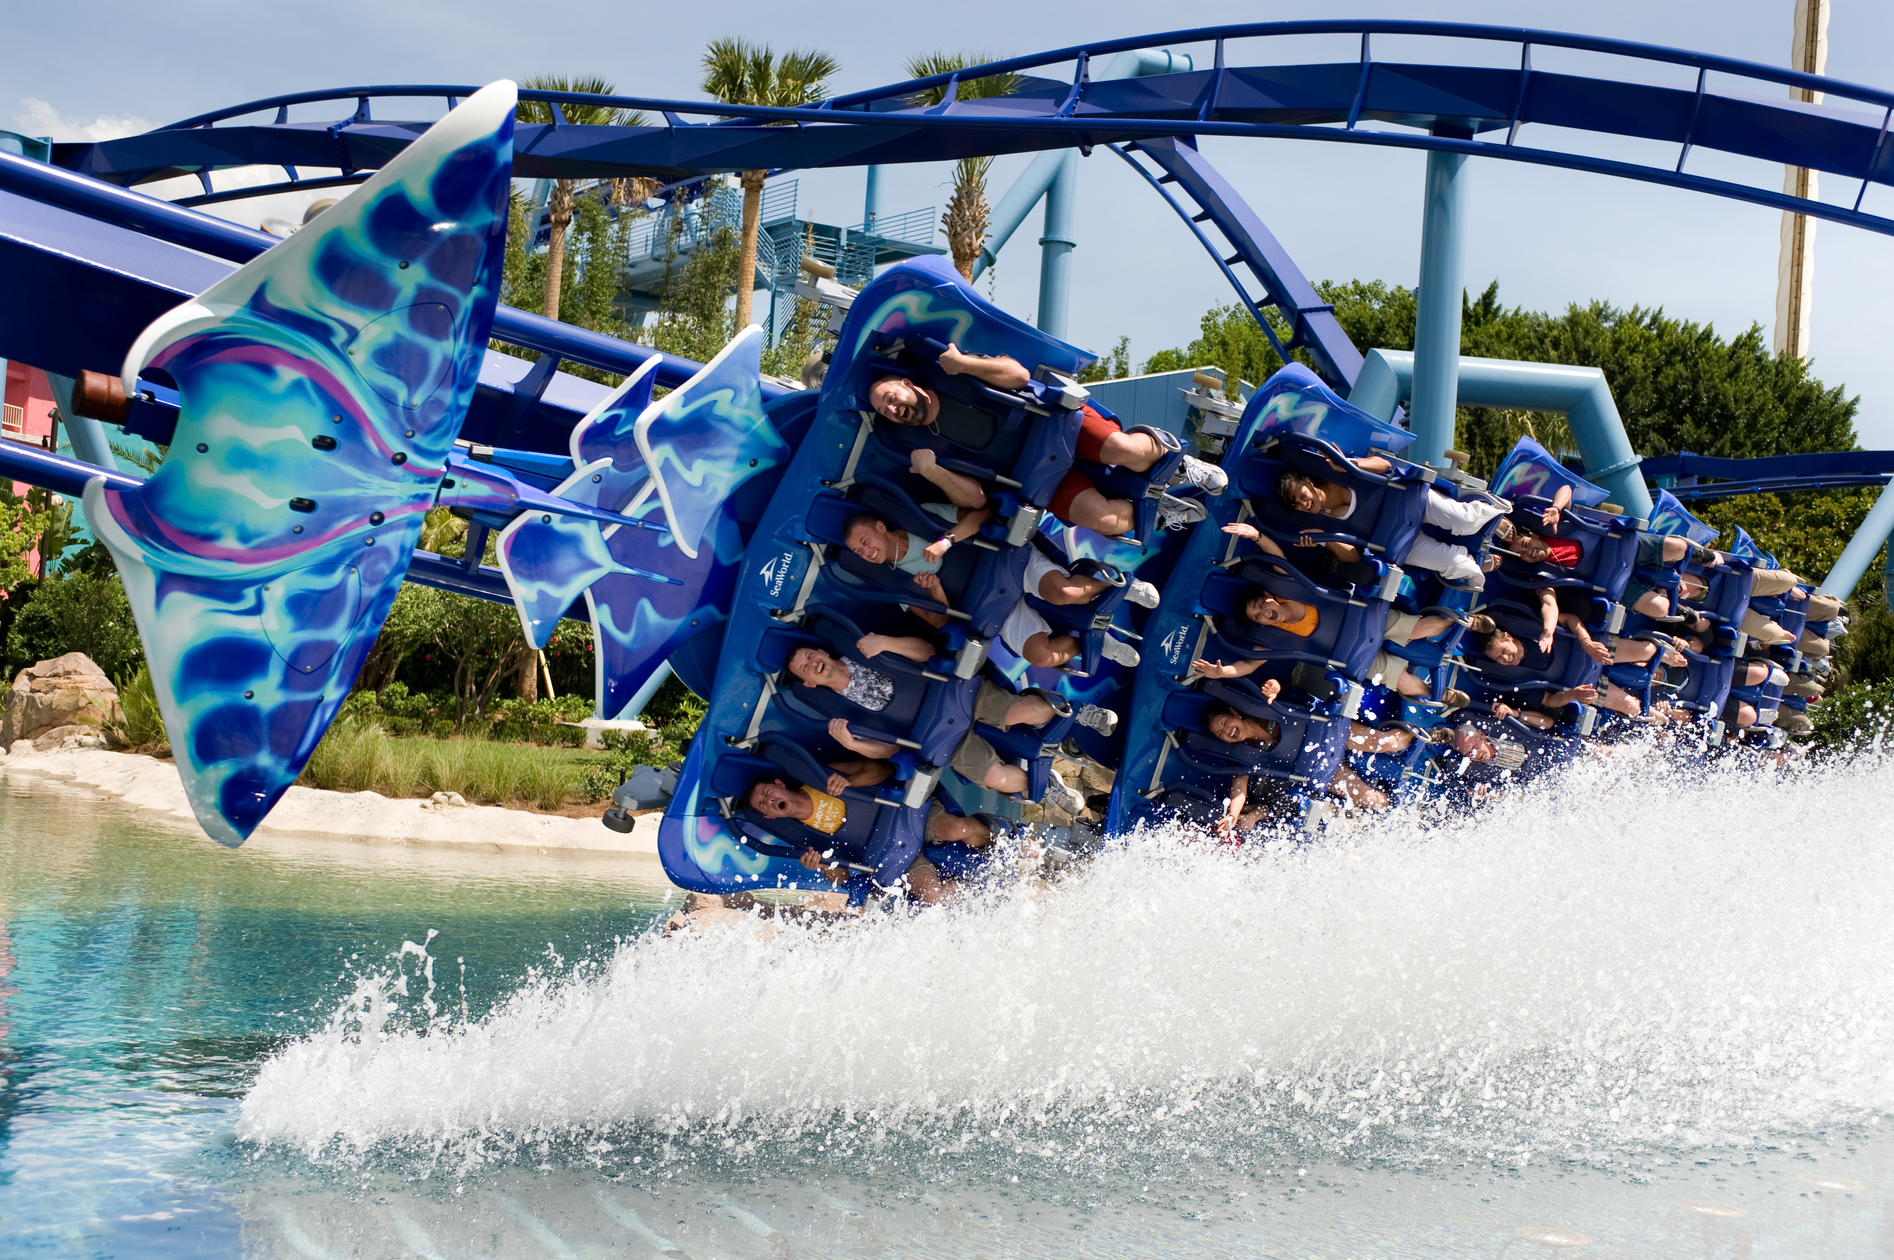

|  |
| --- |
| * Behind the scenes tour of Sea World’s Manta roller coaster. See what it takes to operate a world class coaster. * Get the inside scoop on the ride Antarctica * Ride Manta and Antarctica * Tour will be followed by a reception close to the park. |
|  |
|  |

An Opening Reception YOU DO NOT WANT TO MISS!!

Greetings!

The University of Central Florida is one of the largest universities in the country and is striving to become the greatest metropolitan research university in the country. The Facilities & Safety organization at UCF is managing the work and the subsequent resource challenges we all have in many unique ways. We are charting our course to greatness here on the University campus by instilling a reliability-based culture within facilities management. UCF is proud to host the 2019 FLAPPA Annual Conference, giving you a glimpse into how similar methodology used for years in other industries can work in a higher educational facilities setting.

Many of you may have heard about reliability centered maintenance, preventive maintenance optimization, and proactive strategies, but have you heard of these within higher education? We want to show you how we have brought these principles to our facilities management work force. When you come to UCF, we will be five years into the process of implementing these methodologies, and will share some of the insights, challenges, successes, and progress we have made. We will discuss what we have done, what we are currently doing and where we plan to go.

Our opening reception on March 13th will include a behind the scenes tour of Sea World’s Manta roller coaster ride. Here you will see the number of preventive maintenance and inspections involved in operating a world class roller coaster attraction, an awesome experience that most people never see. We are asking our Business Partners for their financial support to make this one of the best opening receptions FLAPPA has ever had!

On Thursday, March 14th, we will be hosting several educational sessions from a variety of UCF employees as well as other subject matter experts in the fields of topic. In addition to the educational sessions, we will be hosting the Business Partner Expo in our Student Union Pegasus Ballroom. This will give attendees and our Business Partners an opportunity to network, view demos or product and service offerings, and say thank you for all they do to support FLAPPA and our day to day demands.

There are many opportunities to experience what we know is a unique facilities management approach that can apply to your own processes in many ways. We invite you to join us next March to see how UCF Facilities & Safety is charting its course to greatness. We believe you will take away a glimpse of your future facilities management and will not be disappointed!

Hotel Information



**Orlando East-UCF Area**

**12125 High tech Avenue**

**Orlando, FL 32817**

**407-275-9000**

**Reservation Link:**

[Click Here](http://www.flappa.org/hotel-information.html" \o "Click Here)

**Host Hotel: March 13-15, 2019**





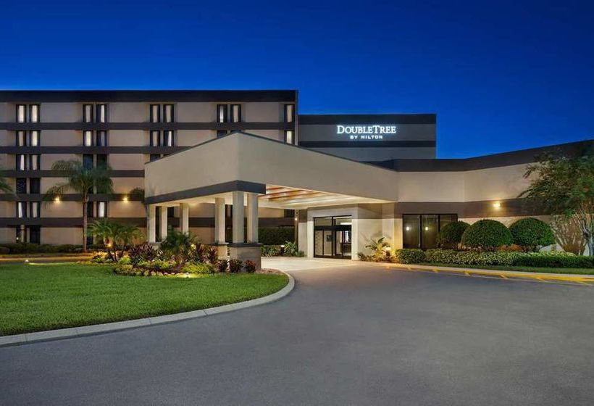

**Join us for the Golf Tournament on March 13, 2019 at 8am at DubsDread Golf Course. Institutional members are always free but be sure and choose “golf” on your registration so we know you are coming. Business Partners free with sponsorships and only $100 per player for tournament and lunch.**

**Register Today!**

* Have you registered for the 2019 Conference?

-All participants must be members of FLAPPA

-All Institutions and Business Partners must have dues up to date

* Looking for a booth? The Expo space this year will be in the Pegasus Ballroom of the Student Union. This space will beautifully showcase your company. A booth is $950 for an 8x10 space with 2 chairs, company name and registration for 2 participants.
* Looking for a unique way to make your company stand out a little more? Consider putting your logo on some of our great giveaways. Contact Cindy for more information.
* Sponsorships still available. Strategic placement at the Expo. Ability to present your company. Company name placed in printed material. Golfing opportunities. Place items in the conference bag. Sponsor the hospitality suite.
* Great accommodations. Awesome food/drinks throughout the conference. Free transportation to reception and UCF daily.
* Unique Educational Track that will interest everyone. Exciting tours on Friday to get first hand information on what is happening at UCF.

[Register Now!](http://www.flappa.org/" \o "Register Now)

Questions? Contact Cindy Lamerson:

[info@flappa.org](mailto:info@flappa.org)

561-319-4663



**The purposes of FLAPPA are to foster mutually supportive objectives among Florida higher educational facilities organizations; to promote relationships that provide personal and professional development through leadership, educational, and networking opportunities for all facilities personnel; to foster the professional spirit among persons engaged in this work; and to aid and supplement the work of the international organization, APPA, “The Association of Higher Education Facilities Officers.”**

**Florida Chapter of APPA Executive Board**

**President:**Tom Heffernan  
Director of Construction and Sustainability  
Lynn University  
**VP/President Elect:**Ken R. Revell  
Utilities Maintenance Manager  
Florida State University  
**Vice President of Financial Affairs:**Tony Farren  
Seminole Campus Facilities Supervisor  
St. Petersburg College  
**Vice President of Administrative Affairs:**Ron Hultquist  
Manager, Facilities Operations  
Physical Plant  
St. Thomas University  
**Past President:**  
Ken Kropp  
Director of Facilities  
New England Development

\***New Officers being elected soon. Interested in becoming a part of FLAPPA? Contact a Board Member today.**

Questions? Contact Cindy Lamerson:

[info@flappa.org](mailto:info@flappa.org)

561-319-4663